AIR QUALITY MONITORING

OBJECTIVE

Continued exposure to environments with poor air quality is a major public health concern in developed and developing countries. It is estimated that the pollutants responsible for poor air quality cause nearly 2.5 million premature deaths per year world-wide. Significantly, around 1.5 million of these deaths are due to polluted indoor air, and it is suggested that poor indoor air quality may pose a significant health risk to more than half of the world’s population.

Due to its link with industrialisation, societal health problems associated with poor air quality disproportionately affects developed and developing nations – it is estimated that air pollution is responsible for the premature deaths. Remidial action to improve air quality is often easy to implement once airborne pollutants have been detected.

This project provides a combination of process of sensing several gas levels in the air and also the ambient temperature and humidity, thus sensing the quality of the air. The levels of the gases and the temperature is displayed in a LCD display panel , which continuously shows the real time output values of the gas sensors , temperature and humidity sensor.

To measure and display temperature and humidity level of the environment. To combine advanced detection technologies to produce an air quality sensing system with advanced capabilities to provide low cost comprehensive monitoring. To display the sensed data in user friendly format in LCD display panel.

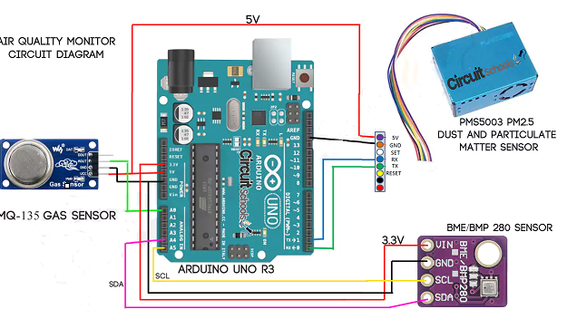

**MQ-135 gas sensor:**

The MQ-135 is a sensor that is responsible for detecting gases such as **ammonia, alcohol, benzene, smoke and carbon dioxide**. It contains basic electronics to be able to interface with a microcontroller, it has 2 outputs, one analog and one digital

**What is it for ?**The MQ-135 is an air quality control sensor which allows the detection of gases such as **ammonia, alcohol, benzene, smoke and carbon dioxide** with a range of **10-1000 ppm (parts per million)**. It is used to prevent high levels of contamination. It is recommended for homes and in industries that handle chemical compounds which can be harmful to health

**How does it work?**The MQ-135 sensor has low conductivity when the air is clean. When the sensor detects gases such as ammonia, alcohol, benzene, smoke and carbon dioxide, the [conductivity](https://www.circuitschools.com/what-is-conductance-and-conductivity/) of the sensors is higher along with the increase in gas concentration. An electro circuit is used that converts the change in conductivity to correspond to the output signal of the gas concentration.

**BME-280 Temperature, humidity and pressure sensor:**

**What is it?**The atmospheric pressure sensor is a plate that is made up of elements such as smd resistors, smd capacitors and a “BME280” chip developed by the **BOSCH company** and has the technology to measure pressure, temperature and humidity.

In addition, everything is integrated in a single piezo-resistive chip that is really compact and low energy consumption. They are also used in some applications such as: warning about dryness or high temperatures, measurement of volume and air flow, calculation of altitude for **auto-pilot systems**, adafruit IO (Internet of Things), home automation control, control of heating, ventilation, air conditioning ([HVAC](https://en.wikipedia.org/wiki/Heating,_ventilation,_and_air_conditioning)) and weather forecast

**PM2.5 Dust and Particulate Matter Sensor**

With the PMS5003 **PM2.5 Air Quality Sensor** you can reliably measure the concentration of PM2.5 particles (which refers to the concentration of particles 2.5 microns in diameter or less

The sensor uses the scattering of laser light to irradiate the suspended particles in the air, then captures the scattered laser light and gets a fairly accurate estimate of the amount of suspended particles per unit volume through a microprocessor.

In the above circuit we connected 3 sensor boards. Initially we connected MQ135 with **5v VCC** power supply and **GND** from arduino and connected the **AOUT** to the analog **A0** pin on Arduino.

Then connected BME 280 with **3.3V**  and **GND** from Arduino to **VIN** and **GND** of BME 280 respectively. then **SCL** pin to **A5** and **SDA** pin to **A4 pin**of Arduino .

PMS5003 is connected to Arduino as **pin1** of sensor to **5V** supply from Arduino and **pin2(GND)** to **GND**, **Pin 4(RX)** of sensor to **Tx** of Arduino and **Pin5(TX)** of sensor to **RX** of Arduino. You can see the above image to know color wire of PMS5003 is for which function.

Data sharing platform IQ AIR INDEX